Date | Event | Accepted as Fact by Fred & Carl | Amplification/ References
1812 June 24 | Napoleon invades Russia with a pan-European Grande Armée of 650,000 men.
1939 Nov 30 | Soviet Union attacks Finland. It ended three and a half months later with the Moscow Peace Treaty on 13 March 1940. |  | Finland was created in 1919 by England and France via the Treaty of Vercilles. https://en.wikipedia.org/wiki/Winter_War Less than two years before the Soviet Union faced off against Nazi Germany during World War II, it waged a bloody war with another adversary: the tiny nation of Finland. Russia’s feud with its Nordic neighbor began in 1939, when Soviet leader Joseph Stalin looked to expand his influence over Eastern Europe. Citing concerns about a potential attack by the Germans, Stalin demanded that Finland’s border with Russia be moved back 16 miles along the Karelian Isthmus to create a buffer zone around the city of Leningrad. He also wanted the Finns to hand over several islands in the Gulf of Finland and lease the Soviets territory on the Hanko Peninsula for construction of a naval base. The Soviets offered a large swath of Russian territory as part of the deal, but the Finns were suspicious of their motives and turned them down. On November 30, 1939, following a series of ultimatums and failed negotiations, the Soviet Red Army launched an invasion of Finland with half a million troops.
1941 Oct 09 | President Roosevelt approved the atomic program |  | President Roosevelt approved the atomic program after he convened a meeting with Vannevar Bush and Vice President Henry A. Wallace. To control the program, he created a Top Policy Group consisting of himself—although he never attended a meeting—Wallace, Bush, Conant, Secretary of War Henry L. Stimson, and the Chief of Staff of the Army, General George C. Marshall. Roosevelt chose the Army to run the project rather than the Navy, because the Army had more experience with management of large-scale construction projects. He also agreed to coordinate the effort with that of the British, and on 11 October he sent a message to Prime Minister Winston Churchill, suggesting that they correspond on atomic matters.
1943 July | Battle of Kursk |  | marked the beginning of a great Soviet counter-offensive which led to the liberation of Kiev and further north Smolensk in the autumn of 1943.
1944 June 23 | Operation Bagration begins |  | https://en.wikipedia.org/wiki/Operation_Bagration
1944 Aug 19 | Operation Bagration ends
1945 Feb 11 | Yalta ends |  | a week of intensive bargaining by the leaders of the three major Allied powers ends in Yalta, a Soviet resort town on the Black Sea. It was the second conference of the “Big Three” Allied leaders–U.S. President Franklin D. Roosevelt, British Prime Minister Winston Churchill, and Soviet Premier Joseph Stalin–and the war had progressed mightily since their last meeting, which had taken place in Tehran in late 1943.  What was then called the Crimea conference was held at the old summer palace of Czar Nicholas II on the outskirts of Yalta, now a city in the independent Ukraine.
1945 April 12 | Roosevelt dies.
1945 April 12 | Harry Truman took over. |  | April 12, 1945 – January 20, 1953
1945 April 25 | Truman learned the details of the atomic bomb. |  | …. it took Stimson and Leslie Groves, who sneaked in the back door so no one would know he was coming over - and George Marshall didn't even attend because he was afraid it would bring to much attention to the meeting - and Leslie Groves - Brigadier General Leslie Groves and Stimson briefed the president with essentially two papers in the Oval Office 12 days after he took office, and he found out exactly how serious this was and exactly what he had to deal with in terms of the nation's nuclear program.
1945 May 8 | V-E Day
1945 May 10 | Final Positions of the Allied Armies |  | 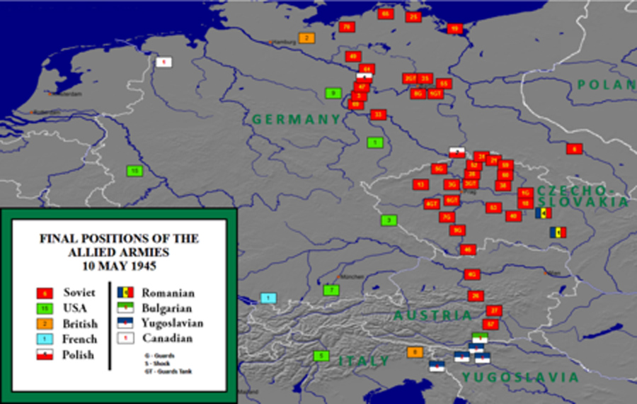
1945 May 22 | Report to Churchill on Operation Unthinkable(1) Pages 1,2,3 |  | 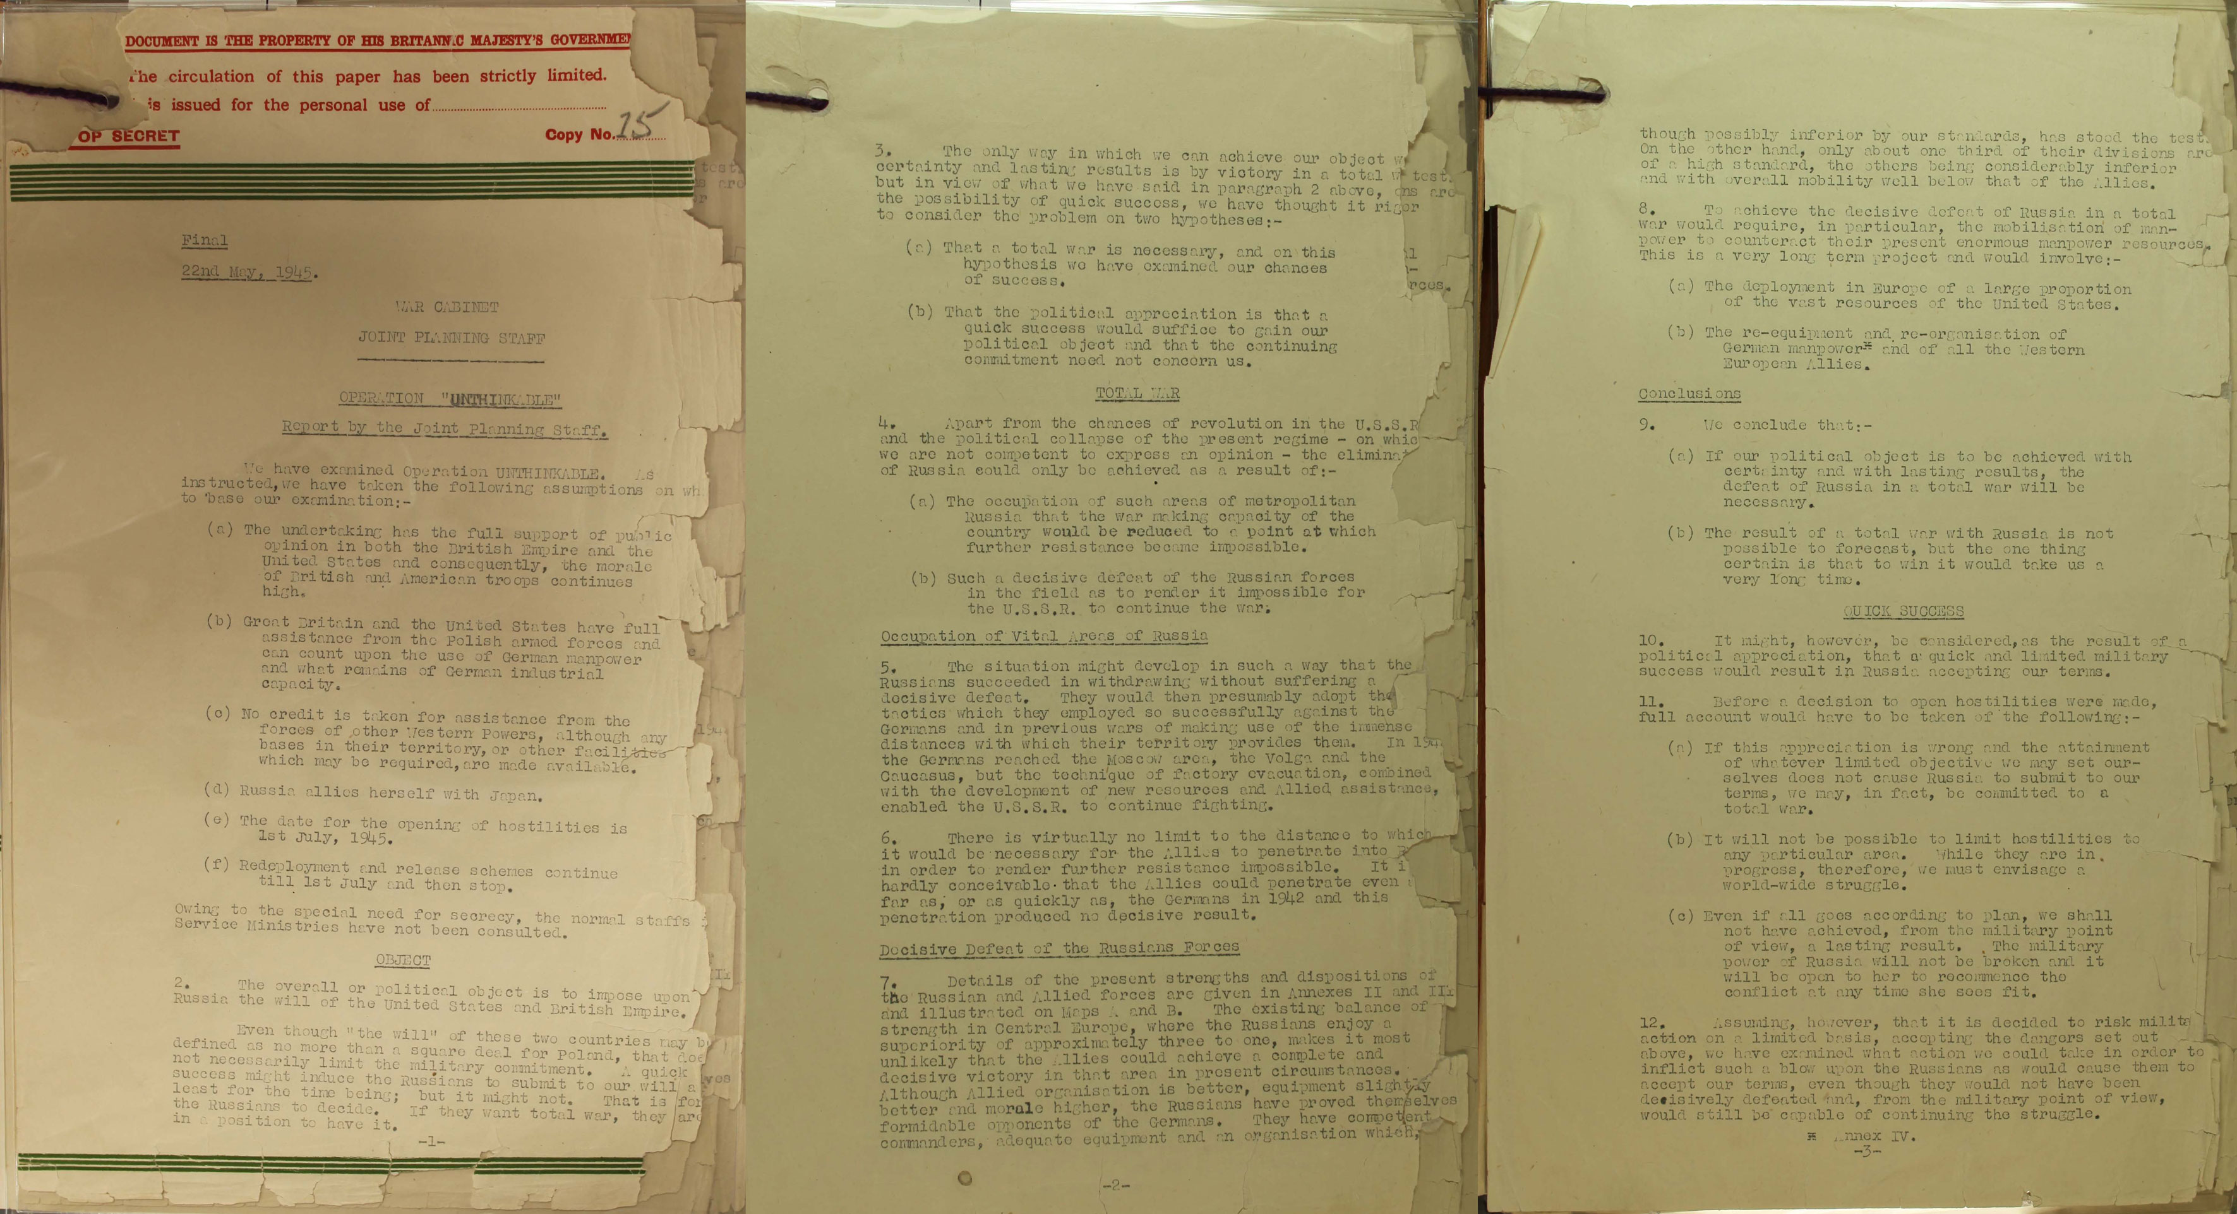
1945 May 22 | Report to Churchill on Operation Unthinkable(1) Assumptions Note assumption (d) 'Russia allies herself with Japan'. |  | 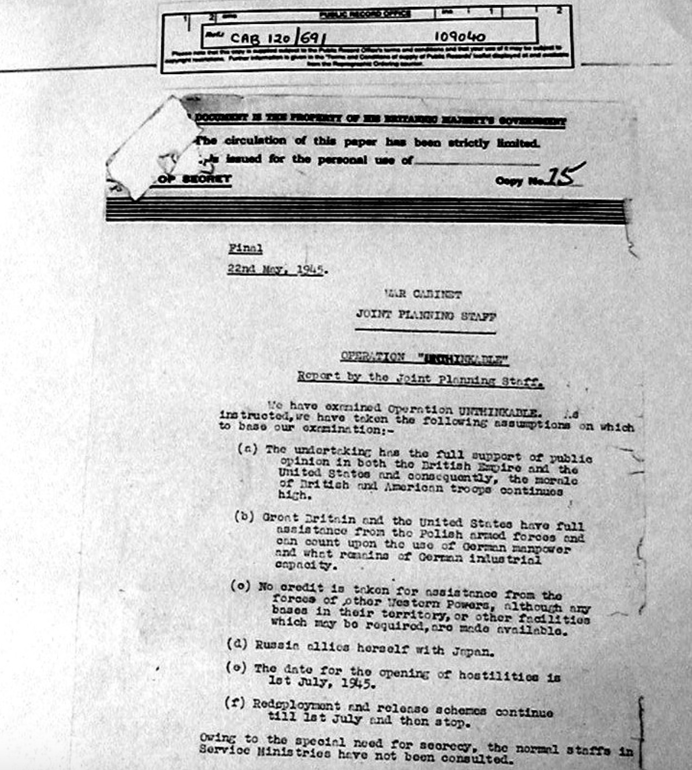
1945 July 1 | Operation Unthinkable(1) was to have begun on this date. Developed by the British Armed Forces' Joint Planning Staff at the end of World War II in Europe. It assumed a surprise attack on the Soviet forces stationed in Germany in order to "impose the will of the Western Allies" on the Soviets. |  | https://nationalinterest.org/blog/the-buzz/operation-unthinkable-britains-secret-plan-invade-russia-22521  The attack would begin on July 1, 1945, to allow operations before the winter weather arrived. They assumed that Soviet intelligence would detect Allied preparations and thus make an Operation Barbarossa–style surprise offensive impossible. Thus the Allies would have a tough fight right from the start. Operation Unthinkable envisioned an offensive by the Anglo-American armies, plus a Free Polish contingent (the Canadians were also informed of the plan). These forces would breach the forward Soviet defenses in Germany. The expectation was that the Soviets would then mass their armor along the Oder and Neisse rivers, which the Soviets had made the new border between Germany and Poland. A gigantic Kursk-like armored battle would be fought around Stettin. If the Allies won it, they would advance to a 250-mile-long line between Danzig and Breslau, where they would halt to avoid exposing their flank to a southern attack from Soviet forces in Czechoslovakia.
1945 | Operation Unthinkable(2) developed by the British Armed Forces' Joint Planning Staff at the end of World War II in Europe. |  | This plan succeeded Operation Unthinkable(1). A defensive scenario, in which the British were to defend against a Soviet drive towards the North Sea and the Atlantic following the withdrawal of the American forces from the continent.
1945 July 16 | First detonation of an atomic bomb.
1945 Aug 6 | at 8:15 a.m., the nuclear weapon "Little Boy" was dropped on Hiroshima
1945 Aug 9 | Second atomic bomb dropped on Nagasaki
1945 Sept 15 | Pentagon sends Leslie Graves a completed War Plan which would “Wipe the Soviet Union off the Map”, per Operation Unthinkable(1). |  | The Pentagon estimated that a total of 204 atomic bombs would be required to “Wipe the Soviet Union off the Map”. The targets for a nuclear attack consisted of 66 major cities.
1946 April 18–20 |  |  | Edward Teller participated in a conference at Los Alamos to review the wartime work on the Super. At the end of the conference, in spite of opposition by some members such as Robert Serber, Teller submitted an optimistic report in which he said that a hydrogen bomb was feasible, and that further work should be encouraged on its development. Fuchs also participated in this conference, and transmitted this information to Moscow.

file:///C:/Data/Political%20Geography/USA/White%20House%20Cabal/Wilkerson%20-%20'White%20House%20Cabal'.html

